1. Write your research questions
2. Empirical study results

**Experiment 1: Predict level of engagement of students**

* 1. Divide your class in three class
     1. Engaged students
     2. Average Engage
     3. Not engaged
  2. Merge above data set with the previous data set
  3. Get prediction accuracy week wise from multiple classifiers
  4. Do feature importance

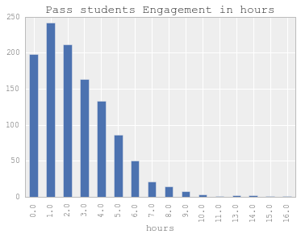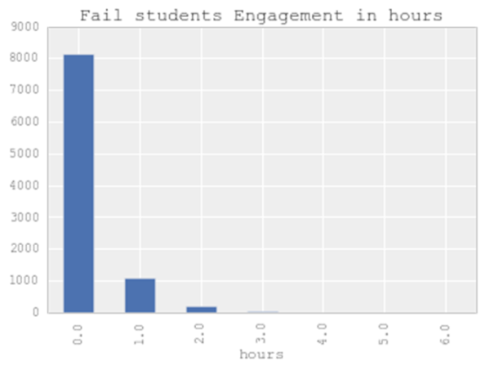

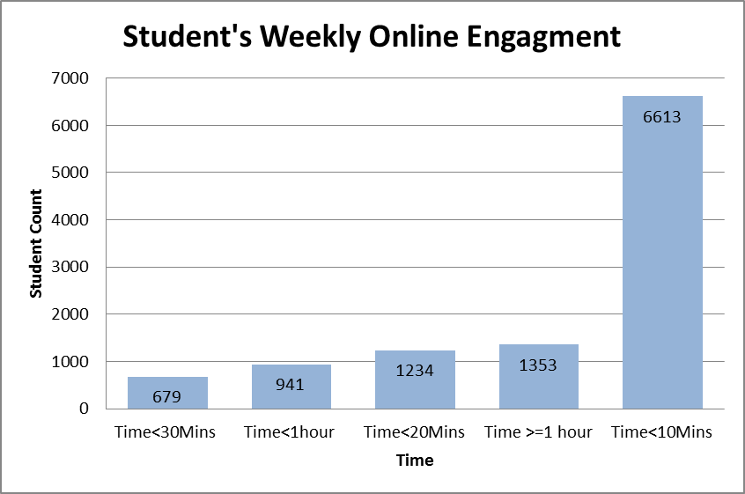

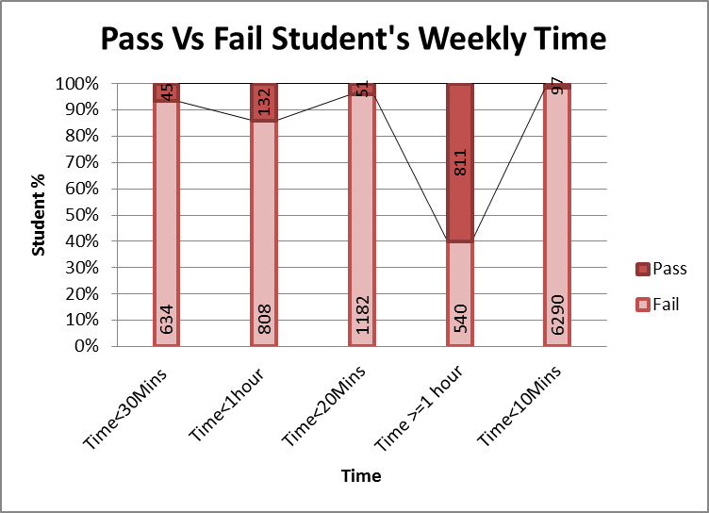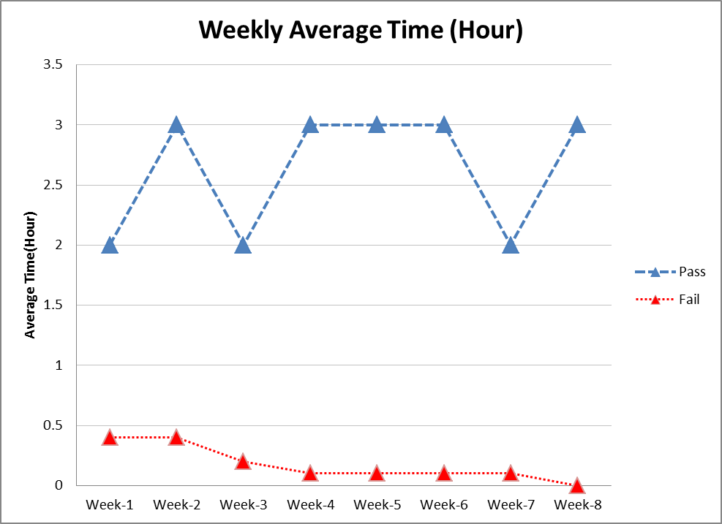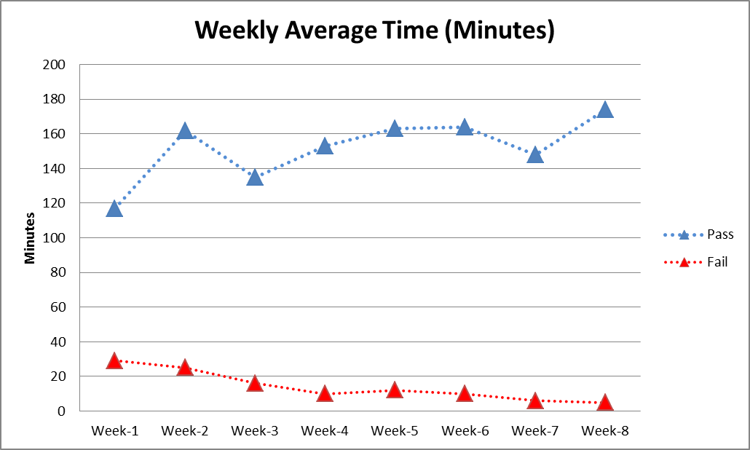

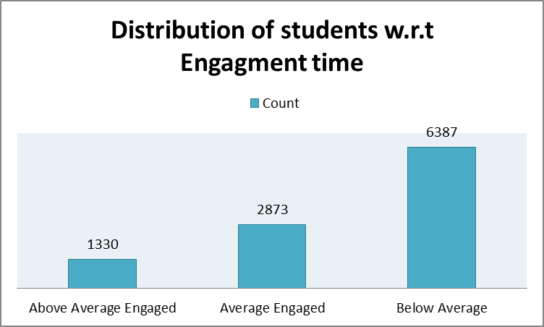

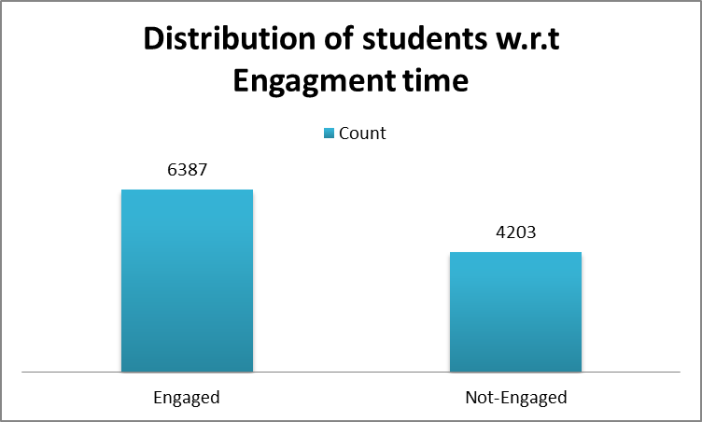

Experiment 1:

Prediction of Engagment class

i.e. BelowAvg, Average, or above average engagement.

Table : Week 1-Prediction Engagment

|  |  |  |
| --- | --- | --- |
| Classifier | Accuracy | F1-Score |
| Logistic Regression | 66.962086 | 0.66 |
| Decision Tree | 67.115471 | 0.66 |
| KNN | 67.292567 | 0.66 |
| Naieve Bayes | 64.399949 | 0.66 |
| SVM | 67.068343 | 0.66 |
| Random Forest | 78.0 | 0.78 |
|  |  |  |

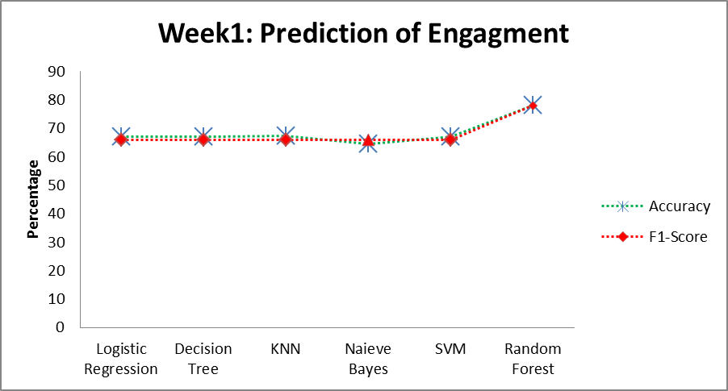

|  |  |  |
| --- | --- | --- |
| Classifier | Accuracy | F1-Score |
| Logistic Regression | 60 | 49 |
| Decision Tree | 67 | 66 |
| KNN | 68 | 66 |
| Naieve Bayes | 28 | 15 |
| SVM | 60 | 48 |
| Random Forest | 84 | 84 |